PedroClaveroDeDios_ProgrammingExercise_2.py

Pedro Clavero De Dios
February 15, 2026

Spam email detector application that scans email messages for 30 spam keywords and phrases.

Function: check_spam
Checks the message for spam keywords and calculates the score.

Parameters:
message (str): The email message to check.

Variables:
spam_score (int): Accumulator for the spam score.
found_keywords (list): List to store keywords found in message.
spam_keywords (list): List of 30 spam words and phrases.

Logic:
1. Initialize spam_score to 0 and found_keywords as empty list.
2. Define list of 30 spam keywords.
3. Loop through each spam keyword.
4. Check if the keyword is in the message.
5. If found, add to score and add keyword to list.
6. Return the score and the list of found keywords.

Return:
tuple: The spam score and list of found keywords.

Function: main
Main function to run the spam detector program.

Parameters:
None

Variables:
email_message (str): The email message from user.
spam_score (int): The spam score.
found_keywords (list): List of spam keywords found.
spam_level (str): The spam level description.

Logic:
1. Get email message from user.
2. Calculate spam score.
3. Determine spam level based on score.
4. Display score, level, and found keywords.

Return:
None
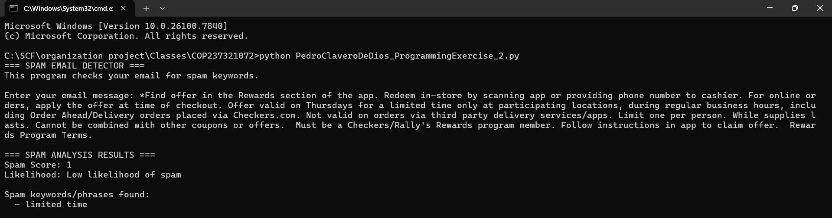
Screenshot:

repository: https://github.com/Pclav34/PC_COP2373

